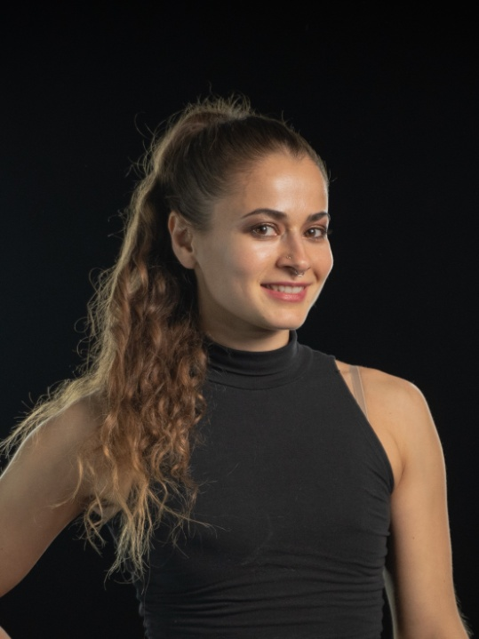

CONTACT
470.213.3898
LenaLani@yahoo.com
Las Vegas, NV

ONLINE
www.lenaalani.com
Instagram @lenalani

SKILLS
+Aerial Rope Specialty
+Aerial Sling Specialty
+Aerial Silks Specialty
+Duo Rope Specialty
+Aerial Straps
+Modern Dance/Movement
+Knowledge of Trapeze/Lyra
+Partner Acro Experience
+Duo Aerial Numbers
+Synchronized Duo Acts
+Ensemble Work
+Roaming Characters
+Stilt Walking
+Aerial Bartending

LENA ALANI
CIRCUS ARTIST/AERIALIST
Height: 5’6”/165 cm Weight: 118lbs/53 kg
Eyes: Brown Hair: Long Brown
US Citizen with a Valid Passport
Fully vaccinated from COVID-19

PROFESSIONAL EXPERIENCE

“THE BEATLES LOVE” BY CIRQUE DU SOLEIL
Las Vegas, NV (July 18th 2023 – Current)
*Aerial Rope Number *Bungee Harness Duo *Harness Dance *Dance Numbers *Character Cues

CORPORATE EVENT AT “LOU RUVO EVENT CENTER”
Las Vegas, NV (June 14th2023 – 1 show)
*Aerial Fabric Solo

“SALVAGE CITY” DINNER SHOW AT EDC LAS VEGAS
Las Vegas, NV (May 19th - 21st 2023 – 15 shows)
*Rope Act Solo

CHERRY BOMBS “MACABARET” TOURING SHOW (OPENING SHOW FOR COREY TAYLOR FROM SLIPKNOT)
US Tour (April 30th – May 10th 2023 – 10 shows)
*Solo Silks Act *Duo Rope Act

MUSIC VIDEO WITH COREY TAYLOR (SLIPKNOT)
Las Vegas, NV (April 24th 2023 – All day shoot)
*Duo Aerial Cube

“ATLANTIS BAHAMAS RESORT” NEW YEAR’S EVENT WITH “DREAM FACTORY”
Atlantis Hotel - Nassau
(December 31st – January 1st 2023 – 7 shows)
*Ambient Performer *Dancer

PRESENTATION FOR CIRQUE ELOIZE
Cirque Eloize Studios – Montreal (December 6th 2022)
+Aerial Rope Solo

CORPORATE EVENTS WITH “ACRO FACTORY”
Palms Casino Resort – Las Vegas
(December 2nd 2022 – 5 performances)
*Aerial Silks *Aerial Sling *Lyra Solo Ambient Performances

“HOMEOSTASIS” LIVE ART PERFORMANCE/INSTALATION
Armory Center for Arts – Los Angeles (April 27th 2022 – 3 shows)
*Aerial Sling Solo *Aerial Ropes Installation Duo Piece
REFERANCES

“Paper Doll Militia”
Rain Anya
510.213.2622

“Shapeshifter Circus”
Jordann Baker Skipper 347.860.2323

“Dream Factory”
David Matz
661.317.8123

“WICKED DREAMS” HALLOWEEN SHOW PRODUCTION
Fremont Street Experience/Four Queens Casino - Las Vegas
(October 1st – October 31st 2021 – 25 shows)
*Silks and Rope Soloist *Group Dance *Roaming Character

“WARPED” TOURING SHOW
7 Stages Theatre - Atlanta (February 15th – 29th 2019 – 8 shows)
Bedell Performance Hall Theatre - Cape Girardeau
(March 14th 2019 – 2 shows)
Modlin Center for the Arts - Richmond (April 24th 2019 – 2 shows)
*Rope Solo *Invented Apparatus Ensemble *Hover Board Dance

“SCOT NERY’S BOOBIE TRAP LA”
“King King” Venue - Hollywood (October 3rd 2019)
*Aerial Hammock Solo

“BURNING MAN PERFORMANCES” - Black Rock City
(August 28th – Sep 2nd 2019 – 6 Shows)
*Aerial Hammock Solo *Rope Solo

“MADE IN TAHOE FESTIVAL – Tahoe City
(May 27th 2019 – 2 shows)
*Aerial Hammock Solo

“SHAPESHIFTER CIRCUS” LIVE ROCK MUSIC SHOW
Los Angeles (October 19th – November 3rd 2018 – 4 shows)
*Solo Rope *Duo Rope *Solo Trapeze *Character

“ROMANOFF RESTAURANT” DINNER THEATRE
Los Angeles (June 1th – June 30th 2018 – 5 shows)
*Duo Silks *Solo Hammock *Character Dance

“DREAM WORLD CIRQUE EVENT”
Los Angeles, CA (August 2018 – 3 shows)
*Ambient Performer *Fire Performer *Aerial Hammock

MOISTURE FESTIVAL
Seattle, WA (March 11th – 25th 2017 – 12 shows)
*Duo Synchronized Hammock Act

CANOPY STUDIO’S ANNIVERSARY PRO SHOW
Athens, GA (March 2nd 2017 – 1 show)
*Duo Synchronized Hammock Act

“REVOLUTIONS” INTERNATIONAL THEATRE FESTIVAL
Albuquerque, NM (November 6th and 7th 2016 – 2 shows)
*Aerial Fabric Ensemble “Crossroads”

“ABSOLUTE ENTERTAINMENT” EVENT
Braselton, GA (June 15th 2015 – 5 shows)
*Aerial Fabric Solo *Aerial Rope Solo *Hammock Solo

“HEAVEN PRIDE EVENT”
Atlanta, GA (October 15th 2015 – 4 shows)
*Solo Hammock/Fire Performance/Character

“FIXATION” NIGHT CLUB WEEKLY EVENT
Atlanta, GA (August - December 2015 – 30 shows)
*Solo Aerial Fabric *Go-Go Dancer *Ambient Lyra *Character

“NEW ORLEANS FRINGE FESTIVAL”
New Orleans, LA (Nov 7th – 10th 2014 – 6 shows)
*Aerial Fabric Ensemble “Crossroads”

“EXPOSED: HUMANITY IN MOTION”
7 Stages Theatre – Atlanta, GA (August 2014 – 4 shows)
*Aerial Fabric Ensemble “Crossroads”

METHODIST CHURCH CHRISTMAS PRODUCTION
Atlanta, GA (December 25th 2014 – 1 show)
*Solo and Duo Fabric *Group Acrobatics

“CIRQUE DU NUIT EN ROUGE”
Delta Museum – Atlanta, GA (July 2014 – 1 show)
*Synchronized Duo Aerial Fabric *Group Acrobatics *Hammock Solo

“NASCAR” RACING EVENT
Atlanta, GA (July 2014 – 4 shows)
*Fabric Solo Ambient Performance

“IMPERIAL OPA CIRCUS” CORPORATE PRODUCTION FOR MICROSOFT
Atlanta, GA (December 2013 – 1 show)
*Synchronized Duo Aerial Fabric

OPERA NIGHTCLUB “SHIT SHOW”
Atlanta, GA (July 2012 – 2015 – 50 shows)
*Aerial Acts *Characters *Stilt Walking

PERFORMANCE COMPANIES | EVENTS
“Insomniac Events”
*EDC Las Vegas 2023 and Other Events
“Cherry Bombs”
Las Vegas, NV 2023
*Touring shows *Local Events *Music videos

“Paper Doll Militia” Aerial Theatre Company
Atlanta/Los Angeles/Las Vegas 2013-Present
*Touring Shows *Aerial Theatre Productions *Creative projects *Teacher Trainings

“David’s Dream Factory”
Las Vegas, NV
*Aerial Acts *Ambient gigs *Roaming Character

“Acro Factory” Talent and Entertainment
Las Vegas, NV 2022
*Solo Aerial Acts *Ambient Aerial Acts *Corporate Events

“Dream World Cirque”
Los Angeles, CA 2015-2019
*Fire Performer *Entertainer *Aerialist *Roaming Character
Corporate Events/Weddings/Birthdays/Holiday Events

“Absolute Entertainment”
Atlanta, GA 2015
*Solo and Duo Aerial *Roaming Character

“Liquid Sky Entertainment” Performance Troupe
Atlanta, GA 2012-2015
*Aerialist *Fire Performer *Group Acrobatics *Stilt Walking *Roaming Character
Corporate Events/Birthday Parties/Weddings/Graduation Parties/Club Events/Holiday Events/Aerial Bartending

Opera Nightclub (Supperclub) Various Events – Atlanta 2012-2015
*Fabric Solo *Hammock Solo *Characters *Fire Performance

EDUCATION/PROFFESIONAL TRAINING

Straps: Stephen Brine (Cirque Du Soleil) ♦ David Isaac Grey (Cirque Du Soleil) ♦ Aaron Kozloff
Rope: PJ Perry ♦ Alex Allan ♦ Terry Crane ♦ Emiliano Ron ♦ Marina Luna ♦ Julia Grace ♦ Allie Cooper ♦ Rain Anya
Flexibility: Yulia Mikhailova (Cirque Du Soleil) ♦ Marina Davidovich ♦ Fit & Bendy Program
Silks and Sling: Joseph Pinzon ♦ Rain Anya ♦ Tanya Burka (Cirque Du Soleil) ♦ Jenn Bruyer ♦ Brett Womback
Lyra: Christina Campolongo (Cirque Du Soleil) ♦ Sita Asevedo (Cirque Du Soleil)
Trapeze: Rain Anya ♦ Marina Luna
Chinese Pole: Evan Westbrook

DANCE/MOVEMENT TRAINING
Ballet ♦ Modern ♦ Jazz
2017-Present

LINGUISTICS AND TRANSLATION BACHELOR DEGREE
“Moscow State Social University”, Moscow, Russian Federation
English and Russian Major, French as second foreign language (2005-2010)

